**EXERCISE 1**

**NAME: Nguyễn Võ Minh Hiếu**

**STUDENT CODE: 3122411057**

**LINK GITHUB: https://github.com/MinhHieu2112/KTPM-NguyenVoMinhHieu.git**

1. **VERIFICATION AND VALIDATION**

**Description:** The purpose is to help users to solve a 2-degree equation (a*x*2+b*x*+c).

**Spec:** Given input of *a*, *b*, and *c*; the system returns the outputs of *x*1 and *x*2 (extreme cases are temporarily not considered)

Two systems are developed as follows.

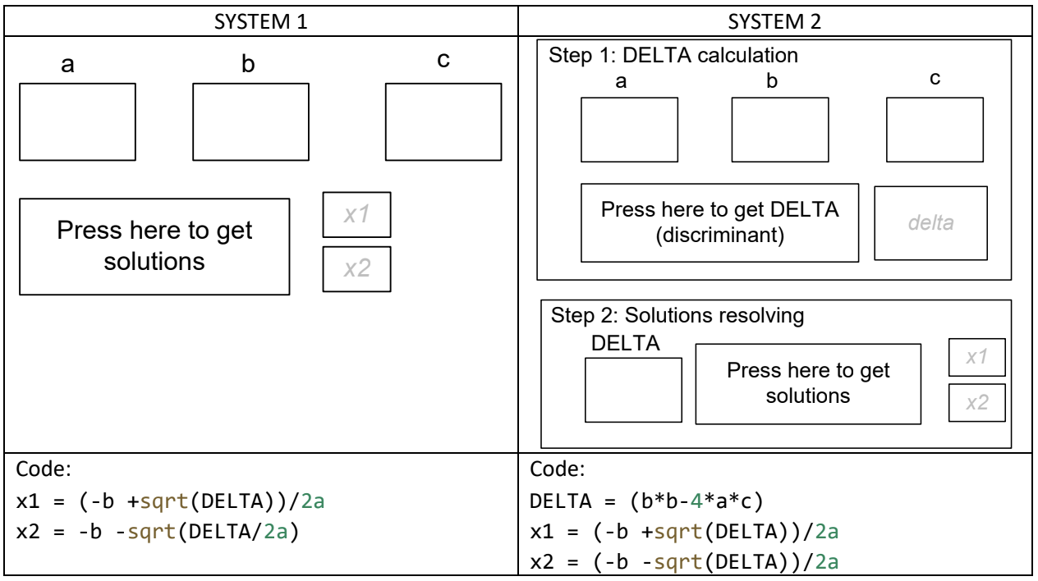

What are the problems of those two systems? Write down your answer here.

In the system 1, mathematically, the problems are the wrong formula for x2 and the calculation of DELTA is not clearly shown. In terms of code syntax, there is no clear declaration of the variables like a, b, c, x1, x2 and there is no definition for the DELTA’s variable.

In the system 2, this looks better than system 1. However, it still has some problems, such as the lack of clear declarations for the variables like a, b, c, x1, x2, DELTA and the absence of handling cases when a = 0 or DELTA < 0.

1. **TEST-CASES**

**Description:** Some input values

1. How many test-cases we need for the following function *f*1. What are they?

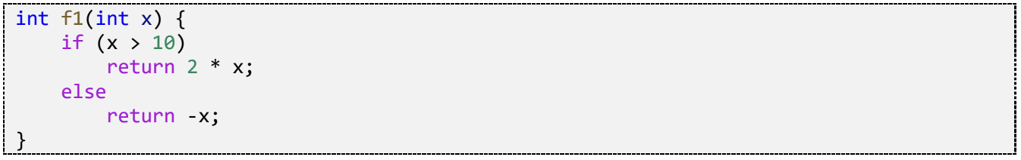

Thus, minimum 2 test cases are required, but to test the boundary, we may use 3 test cases. They are x=9, x=10, x=11.

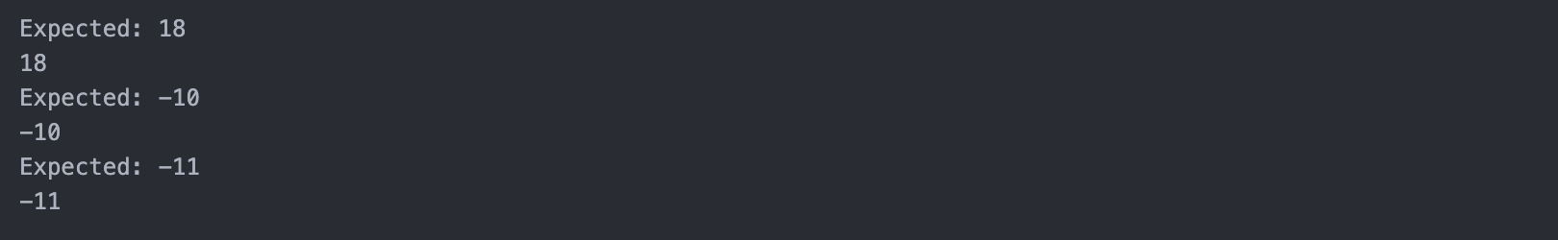

1. Check if your test-cases can detect error if *f*1 is implemented as follows

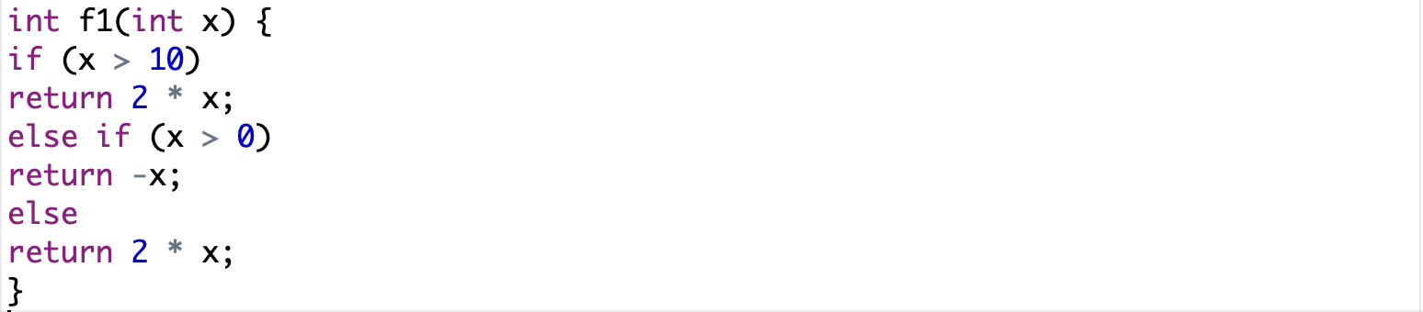

In this case, there are 5 test cases we need test to this function. They are x=11, x=10, x=5, x=0, x=-3.

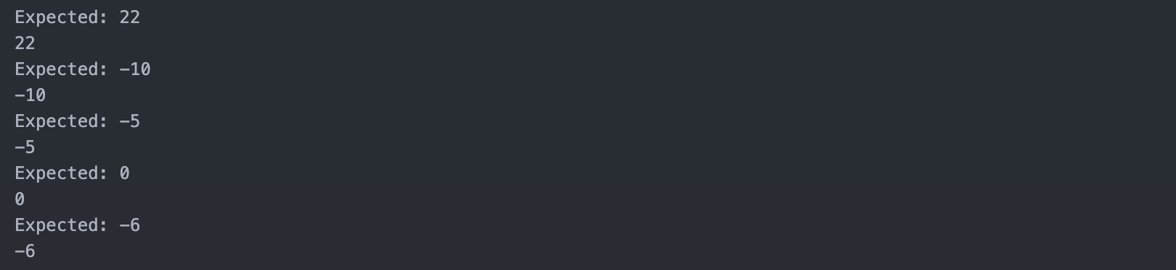

1. How many test-cases we need to test this function? What are they?

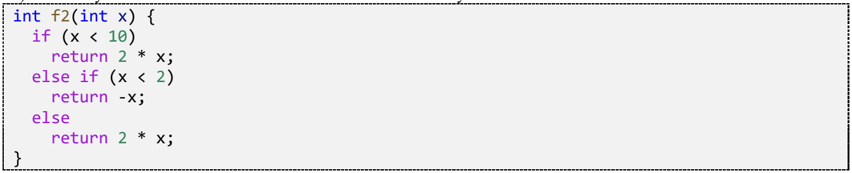

In this case, there are 3 test cases we need test to this function. They are x=9, x=10, x=11.

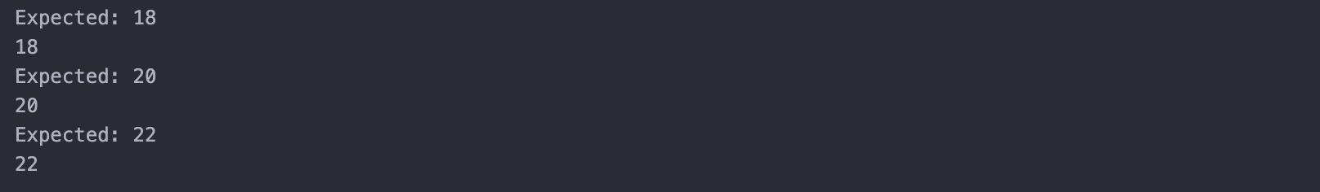

1. How many test-cases we need to test this function? What are they?

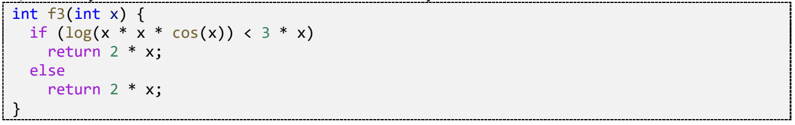

In this case, there is 1 test case we need test to this function. It is x=1.



1. Check if your test-cases can detect error if *findMax* is implemented as follows

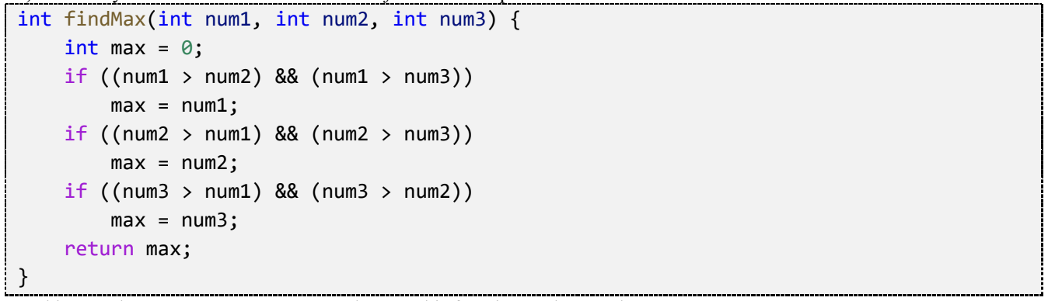

In this case, there are 7 test-cases we need to test this function. They are (3,2,1), (2,3,1), (1,2,3), (3,3,1), (3,1,3), (1,3,3), (3,3,3).

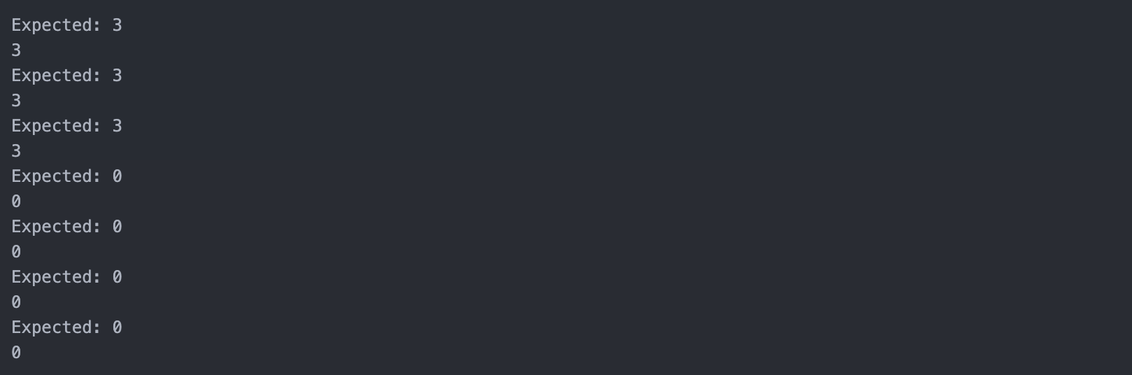

**III. PRATICE 1**

* Mô tả bài toán, các input / output có thể có của bài toán

**Problem description**

The problem is to solve a biquadratic equation (a special case of a quartic equation):

ax4 + bx2 + c = 0

where a,b,c are real coefficients.

This is an idea to solve that problem:

1. Substitute: y = x2
2. Solve the quadratic equation in terms of y : ay2 + by + c = 0
3. For each non-negative solution y ≥ 0, derive the roots of the original equation: x = ±√y

**Input description**

Three real numbers a, b, c (which can be positive, negative, or zero).

**Output description**

Depending on the values of a, b, c, the program will output:

1. "Infinite solutions" if a = b = c = 0.
2. "No solution" if the equation has no real roots.
3. "The equation has n real solution(s): ..." if real solutions exist, where:
   * n=1: only one real root (case y=0).
   * n=2: one positive solution of y or a double positive root.
   * n=3: one root y=0 and another positive root.
   * n=4: two distinct positive roots y1, y2 > 0.

* Xây dựng các test cases kiểm tra tính đúng đắn chương trình

|  |  |  |  |
| --- | --- | --- | --- |
| Test | Description | Input | Output |
| 1 | Infinite solution | 0 0 0 | Infinite solution |
| 2 | No solution | 0 0 5 | No solution |
| 3 | 2nd degree, negative root | 0 2 -8 | The equation has 2 real solutions: 2, -2 |
| 4 | 2nd degree, negative root | 0 2 8 | No solution |
| 5 | 4nd degree, < 0 | 1 2 3 | No solution |
| 6 | 4nd degree, = 0, negative root | 1 2 1 | No solution |
| 7 | 4nd degree, = 0, y1 > 0, positive root | 1 -2 1 | The equation has 2 real solutions: 1, -1 |
| 8 | 4nd degree, = 0, y1 < 0, positive root | 1 4 4 | No solution |
| 9 | 4nd degree, > 0, there is only 1 solution y 0 | 1 0 -1 | The equation has 2 real solutions: 1, -1 |
| 10 | 4nd degree, > 0, y1 < 0, y2 > 0 | 1 -5 6 | The equation has 2 real solutions: 1, -1 |
| 11 | 4nd degree, > 0, y1 > 0, y2 < 0 | 1 0 -4 | The equation has 4 real solutions: 2 -2 1.41421 -1.41421 |
| 12 | 4nd degree, > 0, both y1 and y2 > 0 | 1 -6 5 | The equation has 4 real solutions: 2.23607 -2.23607 1 -1 |

* Viết đoạn mã tự động kiểm tra chương trình cho bên dưới đúng hay sai?

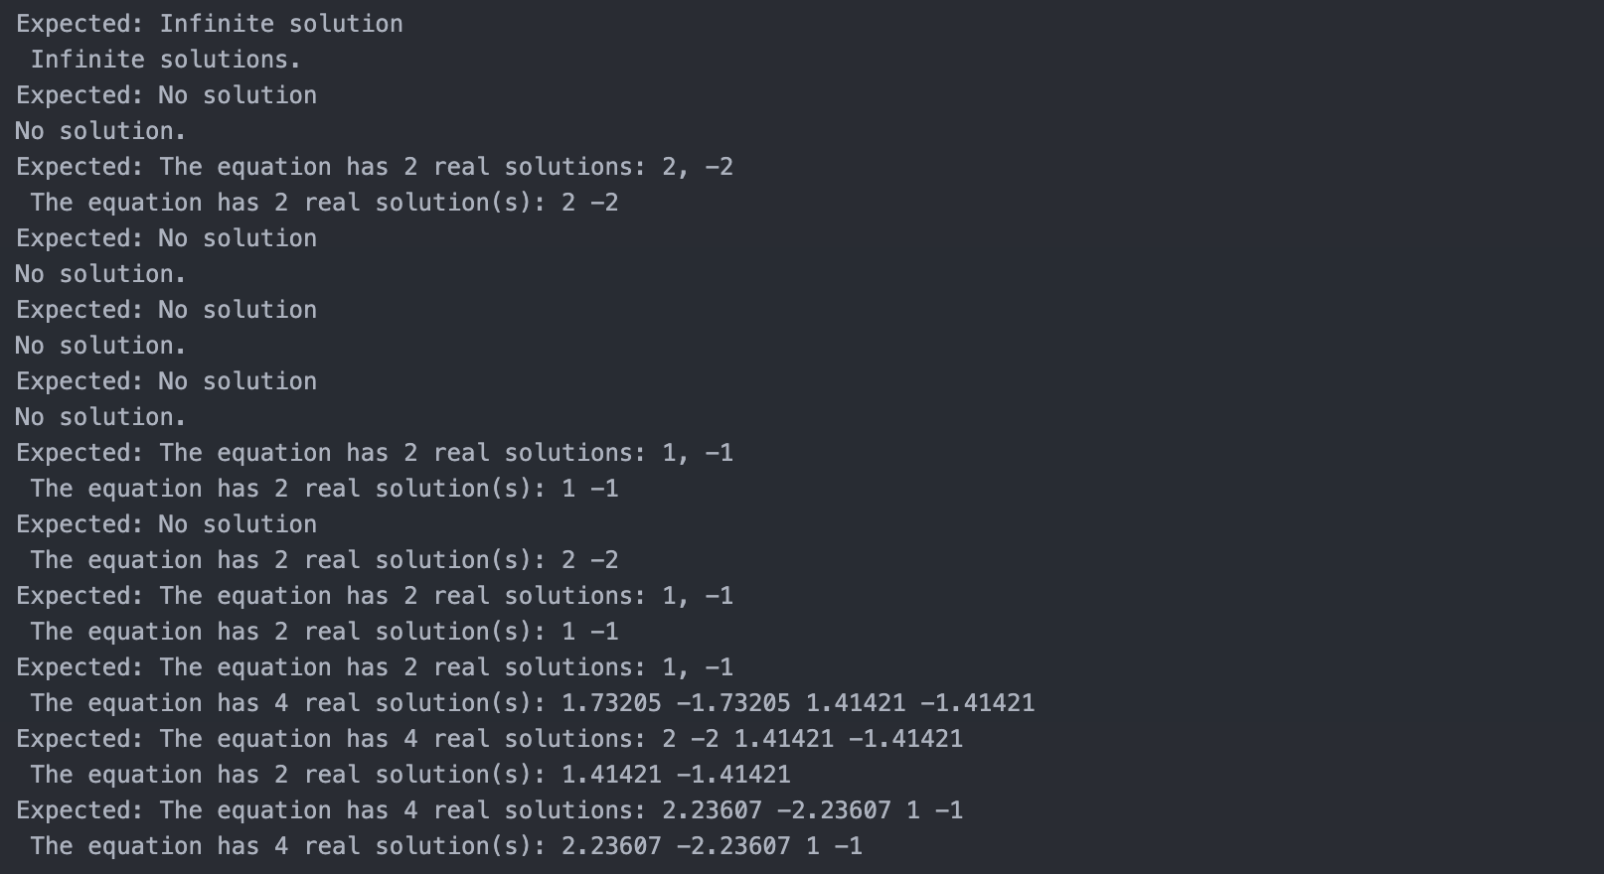

**Code bài toán:**

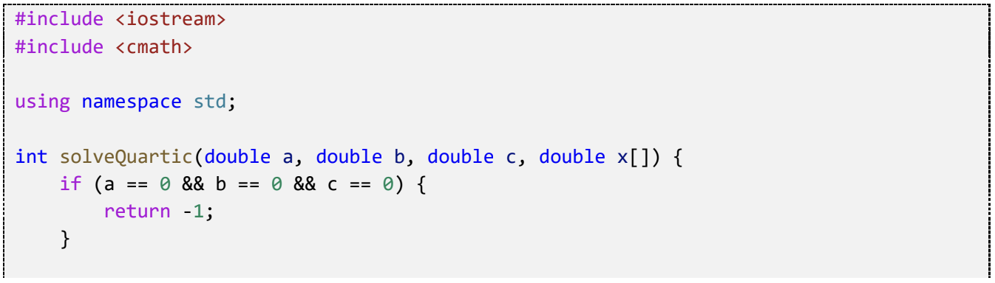

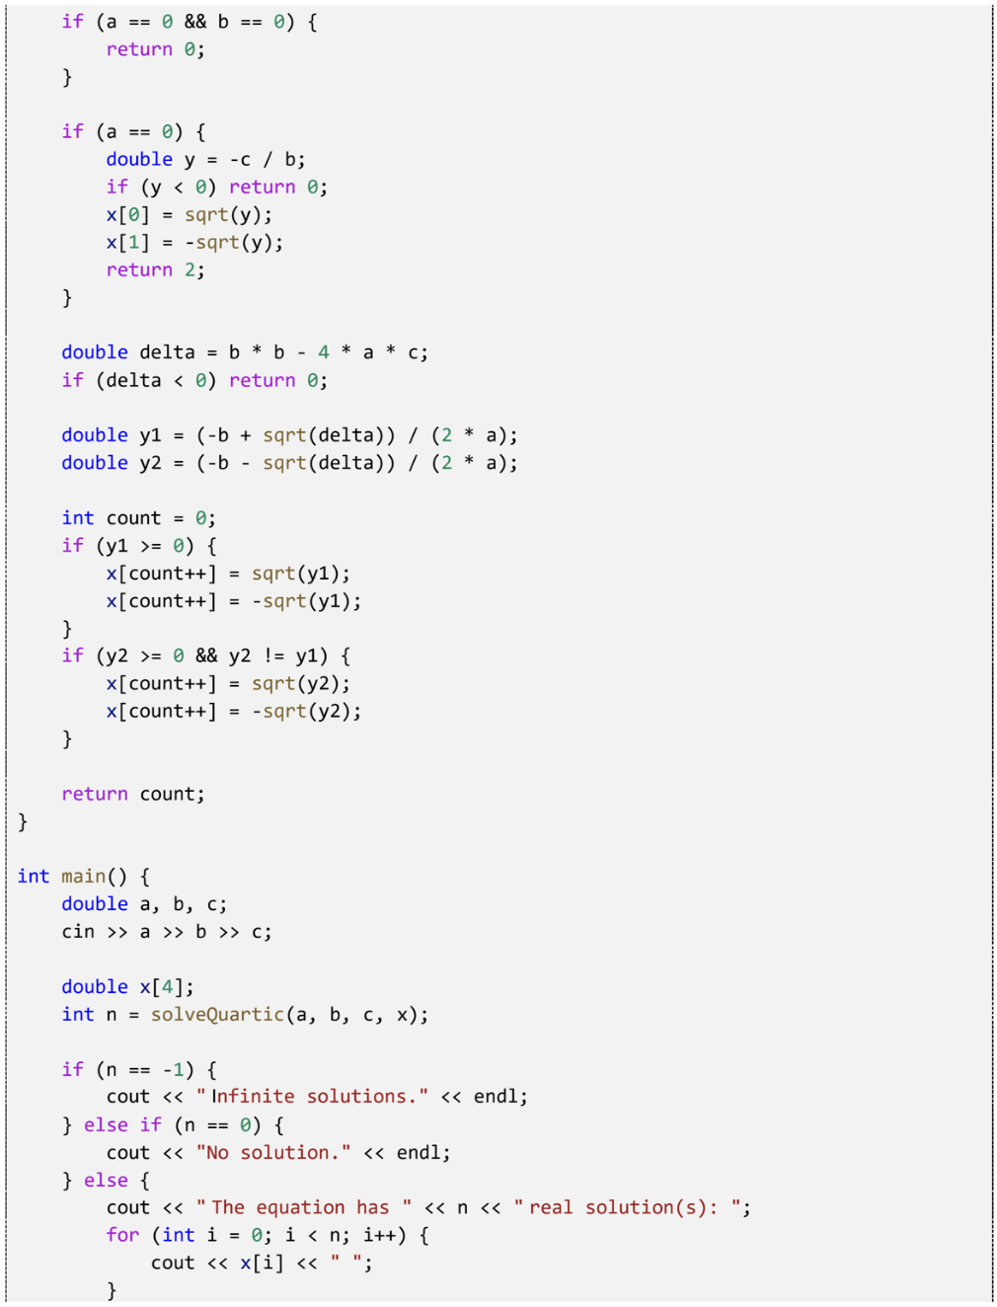

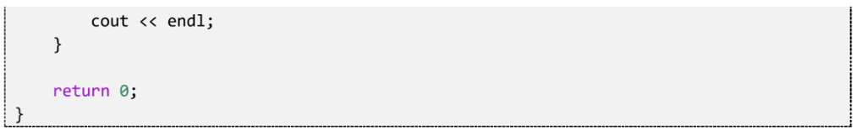

**---o0o---**

**(End)**